**MyGalileoApp** shines spotlight on opportunities for start-ups

***Published:***

*18 December 2019*

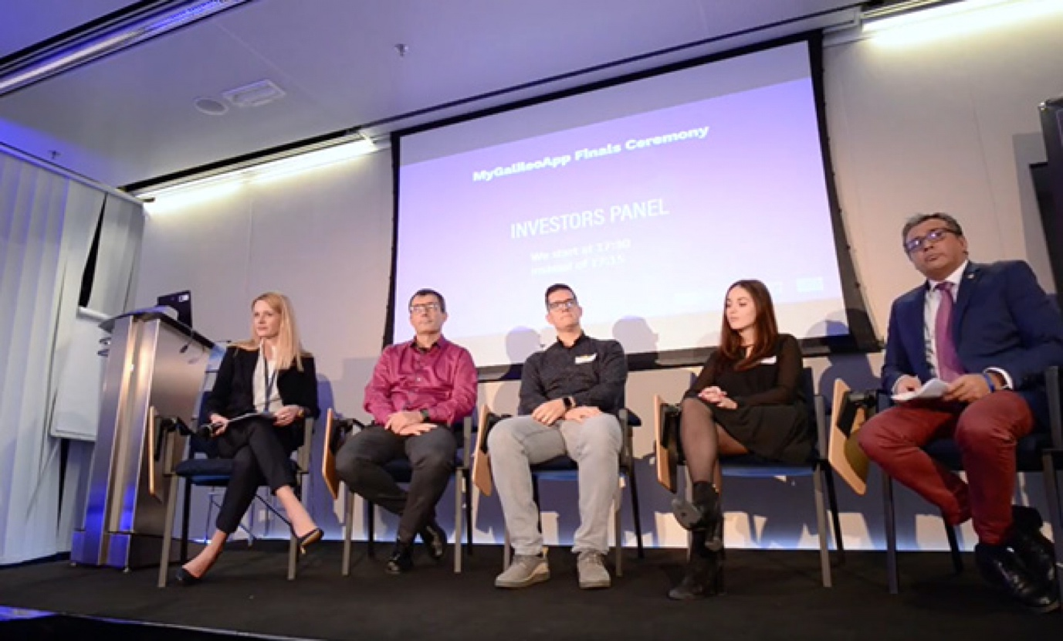

*Start-ups learned about the opportunities available to them at a dedicated MyGalileoApp panel discussion*

**Concrete funding opportunities that are available to space tech start-ups were in focus at the**[**MyGalileoApp competition**](https://www.gsa.europa.eu/mygalileoapp)**, held at the European GNSS Agency’s (GSA) headquarters in Prague on 7 November. At an investors panel discussion held as part of the event, start-ups heard about some of the concrete funding opportunities that are available to them.**

Kicking-off the panel discussion, Marta Krywanis-Brzostowska, Head of Downstream R&D in the GSA Market Development Department, noted that the Agency currently has a portfolio of over 60 projects worth a total of over EUR 120 million. She said that, through Horizon 2020, the GSA is supporting the development of applications, while the Fundamental Elements mechanism targets the development of hardware, such as chipsets and receivers.

Noting that funding is also made available through aviation grants and smaller initiatives like MyGalileoApp and other prizes such as the [Galileo Masters](https://www.galileo-masters.eu/) and [Farming by Satellite](http://www.farmingbysatellite.eu/), Krywanis-Brzostowska said that start-ups stand to receive more dedicated support in the future.

**Dedicated start-up programme**

“We are aware that there is a need to support start-ups, this is why in the new financial framework after 2020 we are planning, along with the European Commission, to define a dedicated programme that will support start-ups,” she said.

**Read this:** [EU space infrastructure guarantees leadership in security and defence](https://www.gsa.europa.eu/newsroom/news/eu-space-infrastructure-guarantees-leadership-security-and-defence)

Thierry Chapuis, space applications expert at CNES (Centre National d’Etudes Spatiales) in France spoke about some of the support available through his organisation, in particular the [Connect by CNES initiative](https://cnes.fr/fr/le-cnes-accelerateur-dinnovation), which was set up to help private and public actors to develop their applications. CNES is also participating in and funding the [ESA Business Incubation Centres](http://www.esa.int/Applications/Telecommunications_Integrated_Applications/Business_Incubation/ESA_Business_Incubation_Centres9) at the French national level. CNES is also working at the aviation level and organising hackathons such as [Act in Space](https://actinspace.org/), the next edition of which will be in April 2020, he said.

Like Krywanis-Brzostowska, Chapuis also noted that start-ups stood to benefit from some dedicated support. “The French government has decided to develop start-ups and a big budget of EUR 400 million has been approved. CNES is responsible for selecting start-ups related to space activities within this programme,” he said.

**Advancing to the next stage**

João Duarte, responsible for early stage venture capital at Lighthouse Ventures, a EUR 23-million fund based in Prague, said that his company supports early stage start-ups with between 50,000 to 700,000 euros per start-up, with EUR 300,000 being the most typical amount. “We also have an acceleration programme where we invest EUR 20,000 for a couple of months to help a start-up go from the idea stage to having a business plan and some early customers. If they successfully complete the acceleration, then they will be eligible for larger investment to take them to the next stage,” he said.

**And this:** [GSA, EIB sign agreement on investment in space](https://www.gsa.europa.eu/newsroom/news/gsa-eib-sign-agreement-investment-space)

Representing UP21, an incubator and seed fund based in Prague, Anna Efros informed the participants that, so far her company had carried out 16 investments in two strategies: incubation with up to EUR 30,000 for 3-6 months, and larger investments of up to EUR 500,000 euros. “We are currently setting up a venture capital fund called START21 which will hopefully amount to EUR 25 million, and also we are co-organiser of the [Start-up World Cup and Summit](https://www.swcsummit.com/), which will be held in April 2020,” she said.

**Money to disperse**

Unlike other similar agencies, the [Italian Space Agency](https://www.asi.it/en/) doesn’t have its own research labs. However, Anilkumar Dave, Head of Innovation and Transfer of Technologies at the Agency, said that it has a lot of government money to disburse. “We will launch the first venture capital fund on space in Italy at the end of this year, where we are the cornerstone investor - but we will not invest in early-stage and seed, but rather in SMEs,” he said.

Marketa Filipenska, International Funding Specialist at the South Moravian Innovation Centre (JIC) noted that her centre had recently opened a European Space Agency BIC where it is helping people with ideas related to space upstream and downstream. “We are providing them with EUR 50,000 and business mentoring, in addition to connecting them to big players in the sector,” she said.

Wrapping up the discussion, Fiammetta Diani, Head of Market Development at the GSA, spoke about a Memorandum of Understanding that the GSA signed with the European Investment Bank (EIB) in September this year, dealing with cooperation on supporting investment in the European space-based service economy. “The MoU aims to give space start-ups a greater portfolio of opportunities and tools to help them to grow,” she said.